# Gathering Point Clouds with Intel RealSense Cameras

The purpose of this document is to create a preliminary design outlining the setup used to scan in military vehicles via Intel RealSense cameras.

**Language Used:** Python

**Link To Main Repository With Scripts:** <https://github.com/brienschmaltz/scan-in-object-using-open3D>

**Prerequisites Needed To Run Scripts:** VS Code, Open3D, Python 3.6 - 3.9

**Prerequisites Needed To Capture Point Clouds:** IntelRealSenseViewer.exe (or just the Intel RealSense SDK)

**Note:** VS Code was the main IDE used, some examples and work will be shown in Juypter and Google Colab.

Contents

Gathering Point Clouds with Intel RealSense Cameras 1

First Experiment 2

Notes 2

Issues 3

Pictures Of The First Experiment 4

How To Capture Point Clouds Via Intel Realsense Viewer 9

Where To Set Distance Threshold 10

Results 11

Second Experiment: 12

Filtering Point Clouds: 17

Conclusion: 19

Other Directions: 19

# First Experiment

## Notes

* IntelRealSenseViewer.exe was used to capture the point clouds. This can also be done programmatically using the SDK in python.

See extra code here for more on the SDK: <https://colab.research.google.com/drive/1GK-OjIeVHS5k7dZE-qr8bMl-FRloFYoC?usp=sharing>

This script goes through reading from a .bag file, examining the data within, manipulating PCD files, viewing PCD’s using Plotly, and more. No environment setup is needed!

* Twelve pictures were taken of the Humvee in 30-degree increments.
* Camera was setup around ten inches away from the Humvee, but it did vary a bit because there was limited space in the setup. An ideal setup should have consistent distance from the target where the cameras were placed around the object in a circle.
* A distance threshold can be set on each camera to gather the maximum amount of point clouds with the least amount of noise and background.
* Completing the experiment indoors allowed the lighting to be controlled and prevented auto-exposure issues.
* The exposure can be adjusted manually but the auto exposure is not as efficient outdoors as it is indoors.
* Lighting conditions can drastically affect the colors and captured point clouds.
* In the second experiment point clouds were darker because of the lighting changing. (overcast vs direct sunlight)

## Issues

* Manual translations were required for each point cloud. (Ideally this can all be found out using geometry and measuring the x and z distance (meters) between the cameras. See figure below for revised method in experiment 2)

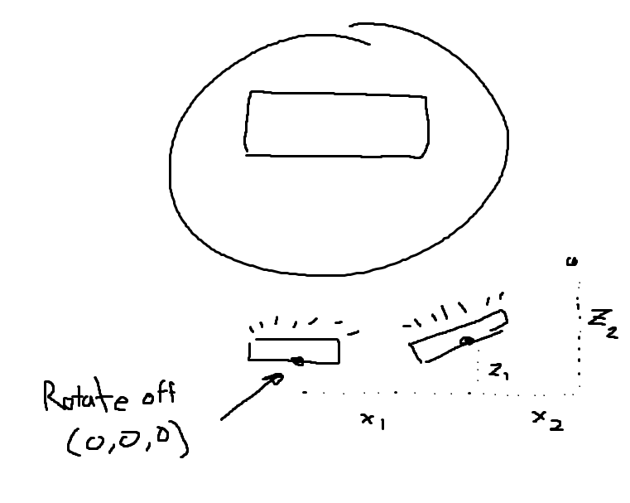

* The x1 and z1 components can be used in open3d to translate the point cloud rather than just guess and align it manually. The results will only be perfectly aligned if the measurements are exact.
* Excess noise was found in certain point clouds which led to extra filtering (need open space)

## Pictures Of The First Experiment

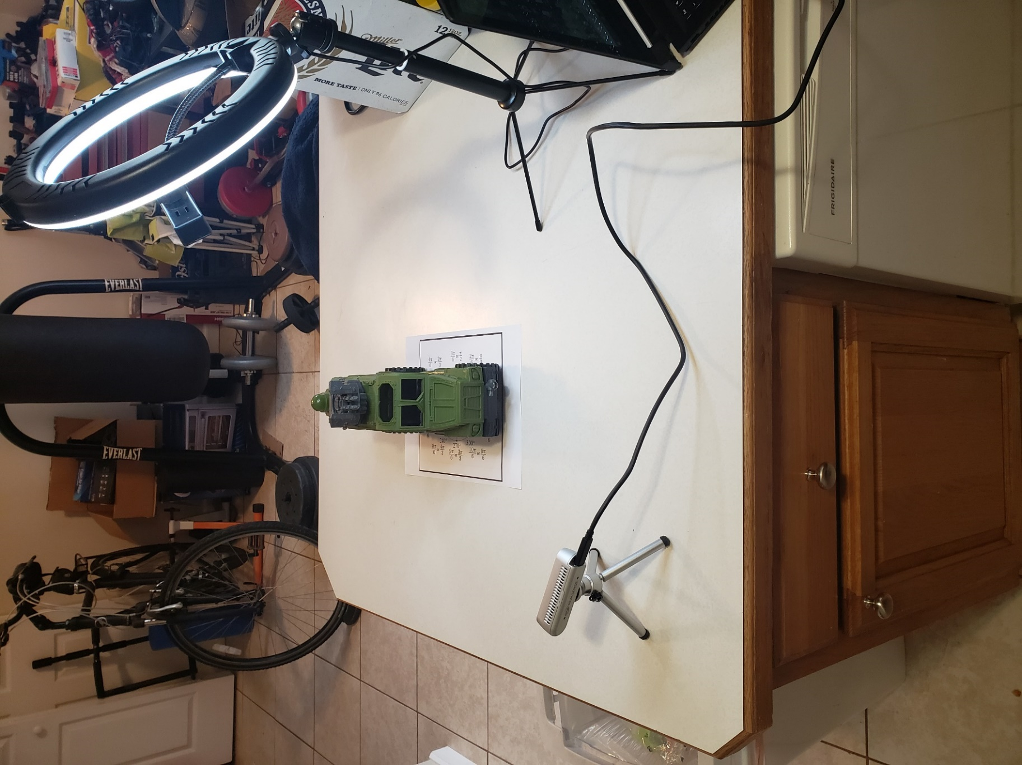

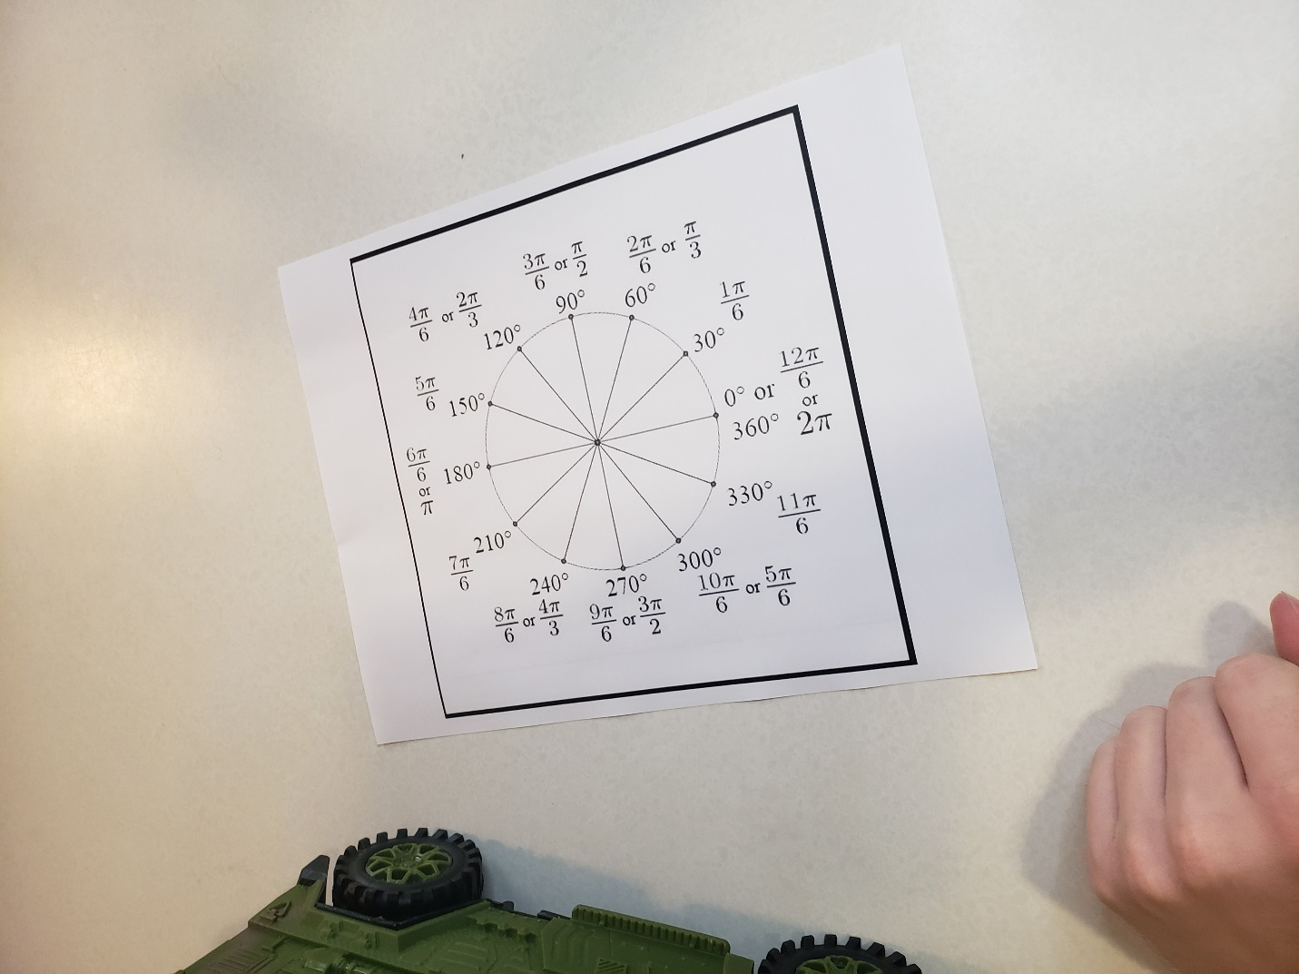

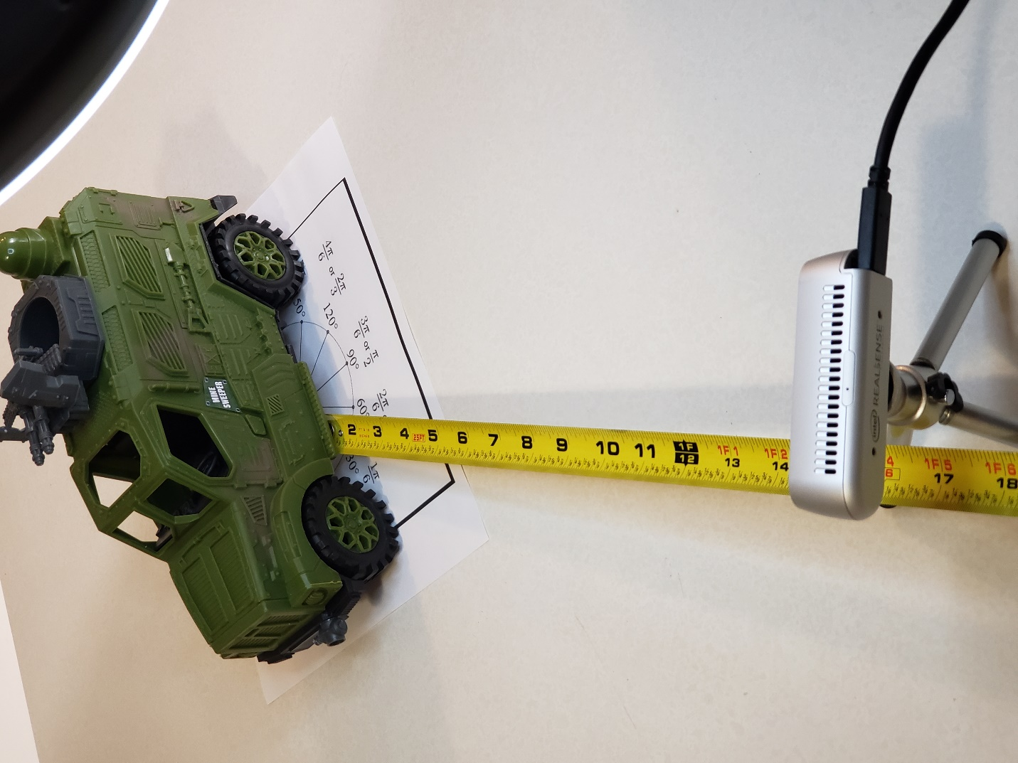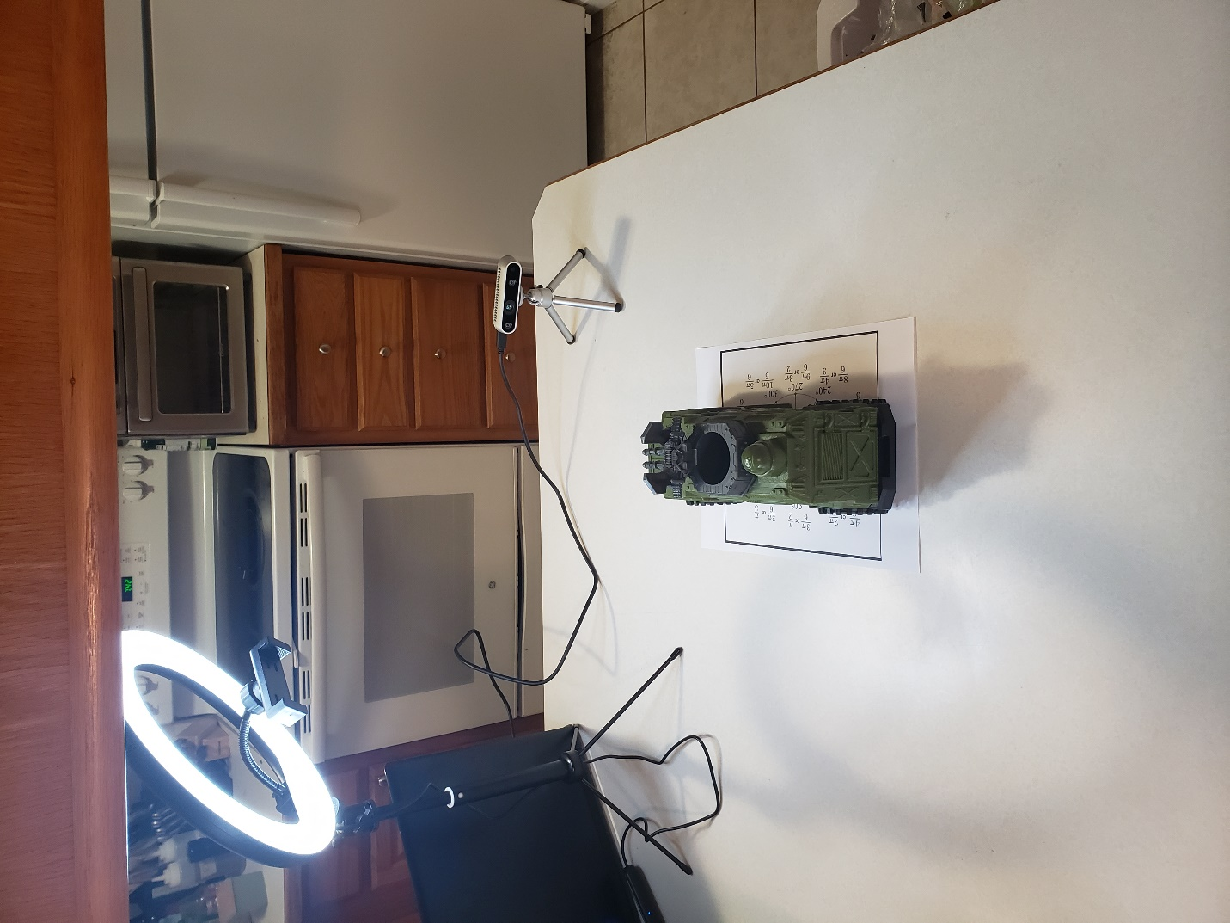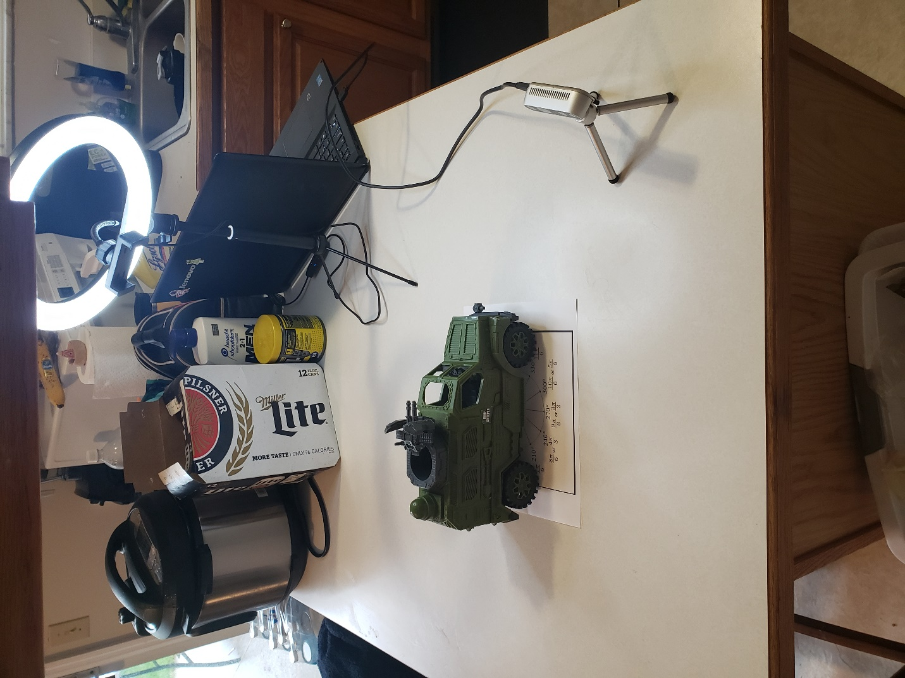

## How To Capture Point Clouds Via Intel Realsense Viewer



## Where To Set Distance Threshold

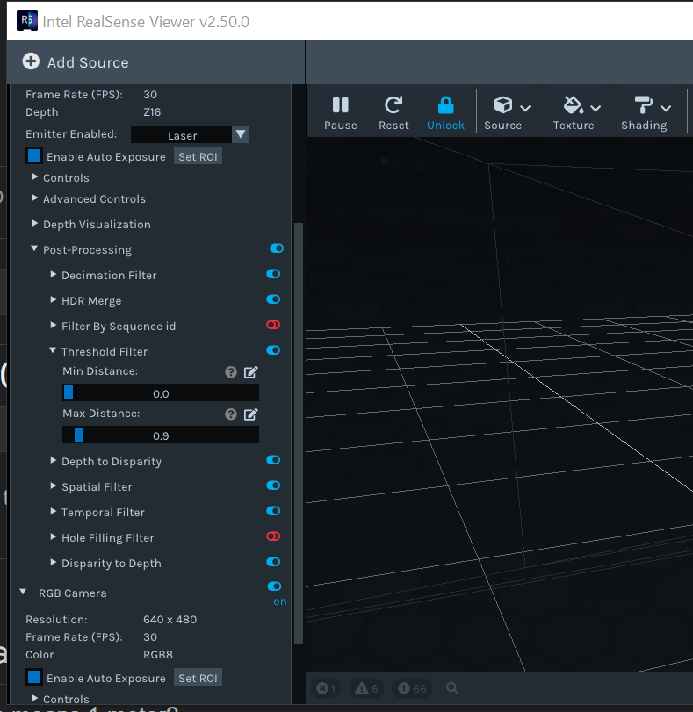

Under Post Processing in the Stereo Camera settings, and it is called a threshold filter.

## Results

# Second Experiment:

## Notes:

* The experiment was conducted outside in direct sunlight. (this may have caused issues as the day progressed and the light moved)
* The goal was to replicate the first experiement but with consistent measurment and placement of the camera.
* The camera was set level and was placed 18 inches away from the center of the toy vehicle for each point cloud gathered
* X1 and z1 were found by loosely measuring the distance between each camera. This could be done better with a larger table and a floor with measurements.
* Each point cloud was rotated pi/6

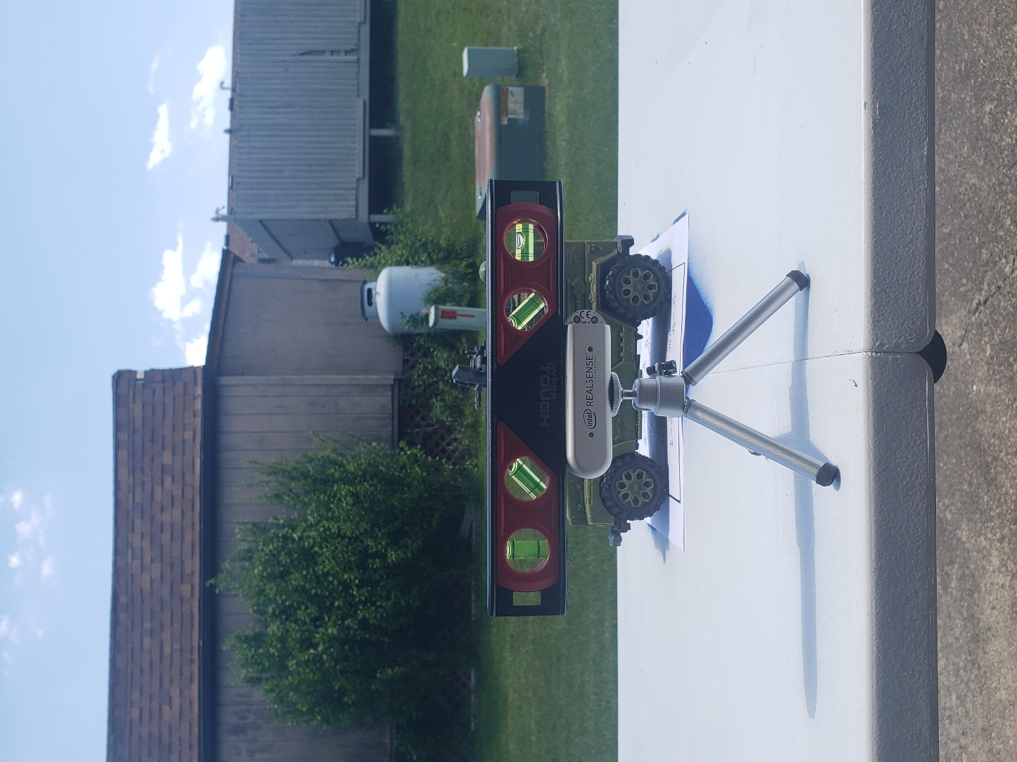

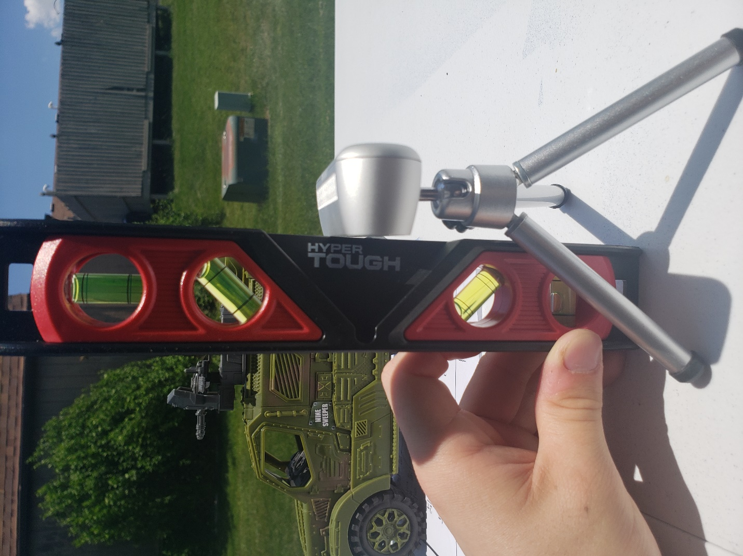

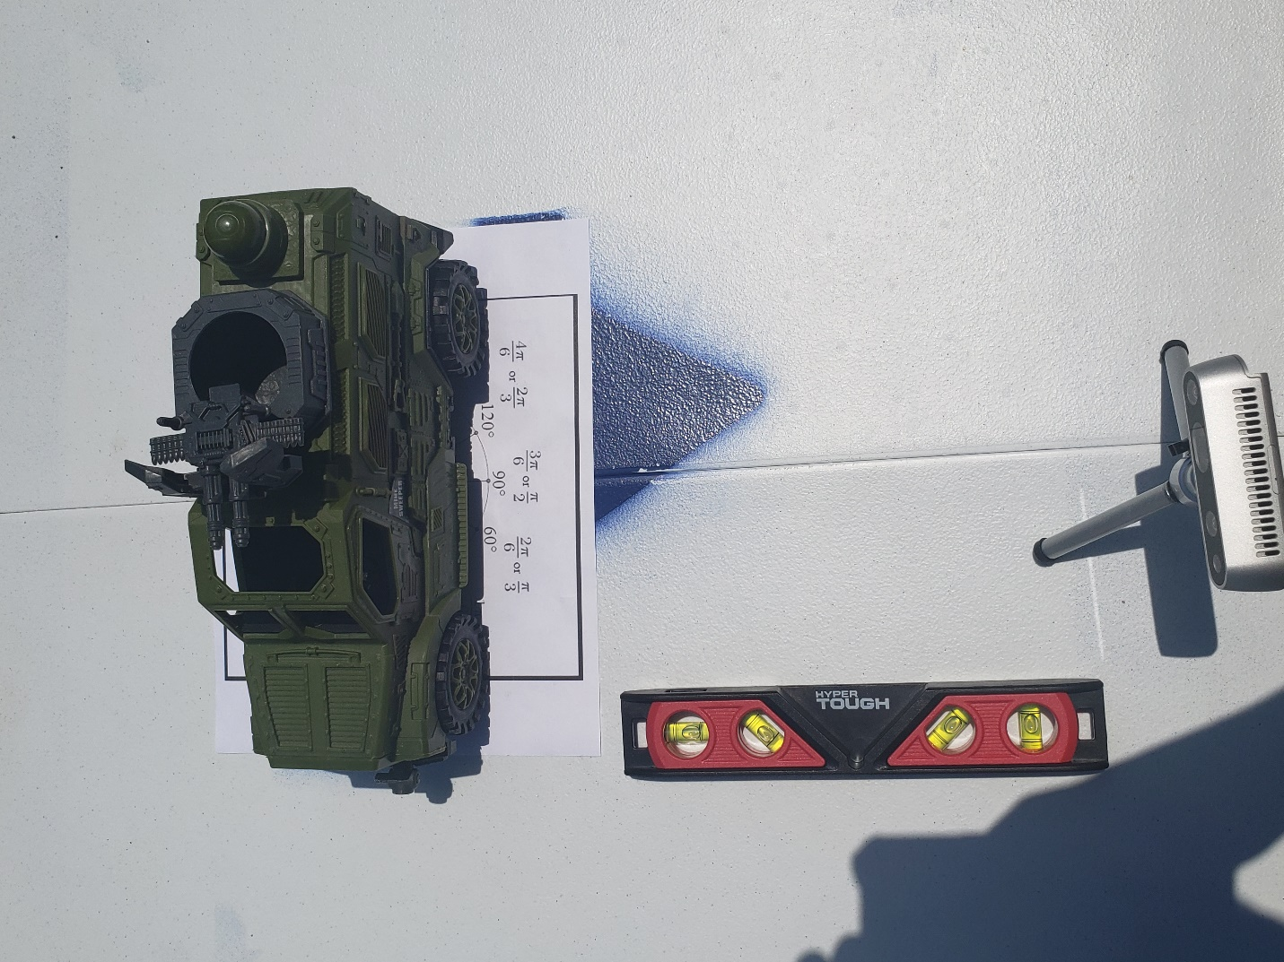

# 

# Filtering Point Clouds:

* Open3d offers a solution to filtering point clouds if you can figure out how to create a box or geometry to surrounding the object without eliminating the object.
* There is a script that demonstrates this (filter_pcd_with_open3d_crop.py), but the bounding box required to crop had to be manually moved, centered, and adjusted to filter out the point clouds.
* So we developed a method using linear regression to remove the floor.
* This essentially draws a line, slightly curved, underneath the vehicle and removes the point clouds.
* To filter a single point cloud with linear regression, see **filter_pcd_with_linear_regression.py**
* To filter multiple point clouds with linear regression, see **filter_pcd_with_linear_regression_loop.py**
* For more examples on how we calculated the floor, see the jupyter notebook file

**Before**

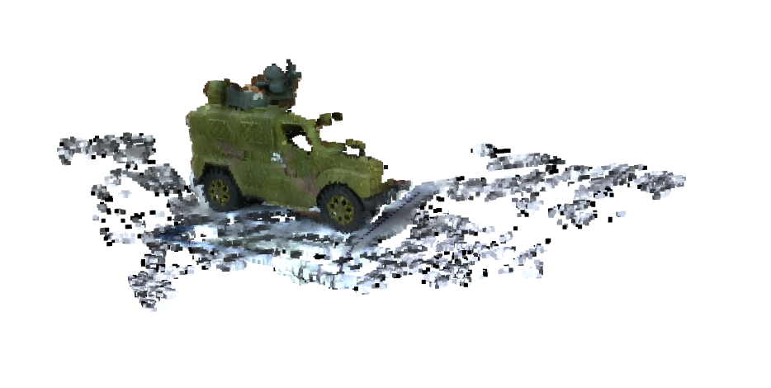

**After**

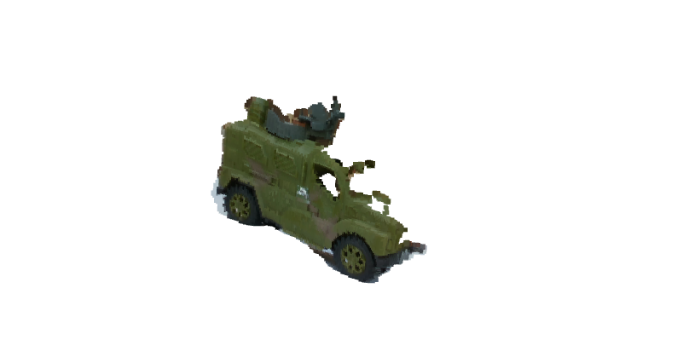

# Conclusion:

# Other Directions:

* Record a .bag file and reconstruct the scene. Rather than setup multiple stationary cameras have a camera fly around the vehicle via a drone and record.

<http://www.open3d.org/docs/release/tutorial/sensor/realsense.html>

* Attempt to use Pyoints instead of open3d. This work is new and the documentation for open3D is sparsely scattered across the internet and thesis work. Pyoints maybe a potential alternative with its own ICP and manipulation algorithms.